**PHASE 1 PROJECT – HERI WAMBUI KIMOTHO**

**INTRODUCTION**

**Problem:** Microsoft sees all the big companies creating original video content and they want to get in on the fun. They have decided to create a new movie studio, but they don’t know anything about creating movies. You are charged with exploring what types of films are currently doing the best at the box office. You must then translate those findings into actionable insights that the head of Microsoft's new movie studio can use to help decide what type of films to create.

**Objectives:**

1. To give a Microsoft a basic understanding of the industry
2. To help Microsoft explore what types of films are currently doing best
3. To give Microsoft actionable insights to create a successful movie studio

**Business Understanding  
Number of firms**

From our research we found that the movie industry has 257 existing movie studios already.

Out of those 257, only 10 movie studios have more than 100 movies released. These include;

1. IFC
2. Uni.
3. WB
4. Fox
5. Magn.
6. SPC
7. Sony
8. BV
9. LGF
10. Par.

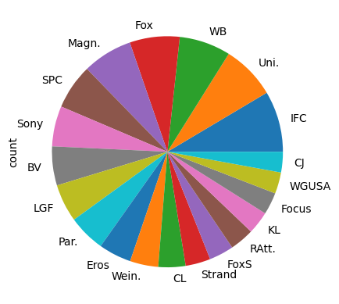

**No. of movies coming in relation to years**

From the data we also aimed to see how many movies were coming out each year.

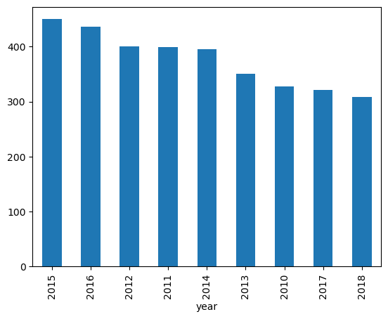

From the data the trend we see is that in the recent years, the number of movies coming out have decreased.

The year with the highest number of movies released was 2015.

The year with the lowest number of movies produced was 2018, the most recent year in our data set.

**Data Analysis**

1. **Genre count**The number of genres in our data set were 254.

The top genres being:

* + 1. Drama|Mystrey and Suspence
    2. Drama
    3. Comedy|Drama
    4. Comedy
    5. Art House and International|Drama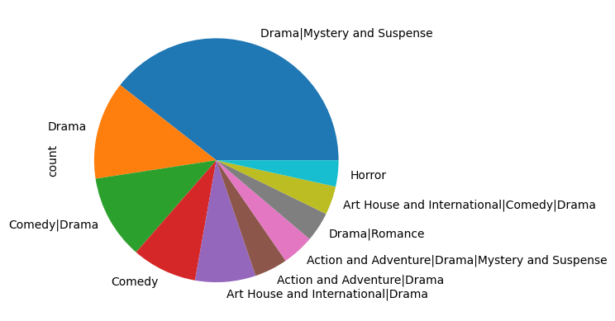

1. **Most popular day/month**

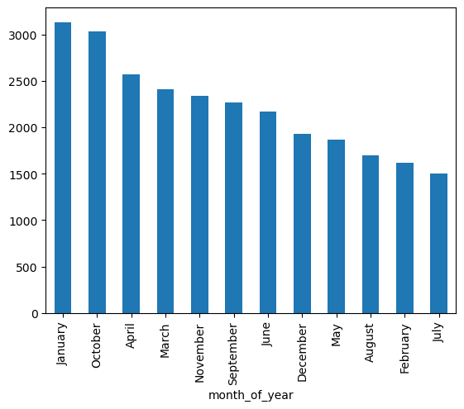

The most popular month to release movies was January with over 3000 movies released then.

The least popular month to release movies was July with just a bit over 1500 movies released then.

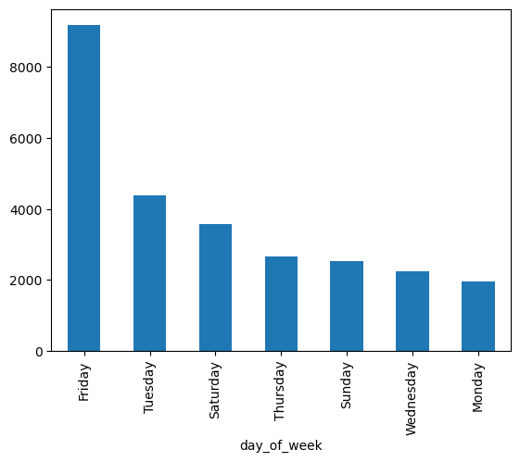

The most popular day of the week to release movies was Friday by a significantly large proportion.

Over 8000 of the movies put out in the recent years were released on Friday.

The least popular day to release movies was Monday with just about 2000 movies released then.

2. **Most popular directors and writers**

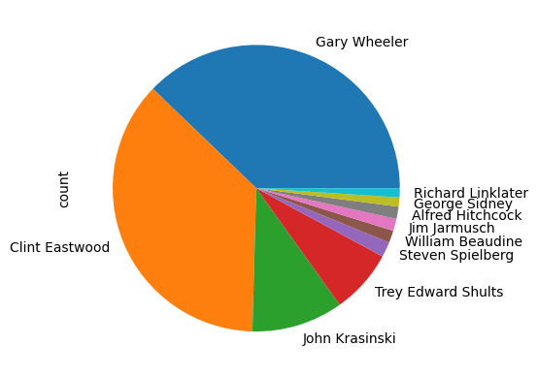

The most popular director to work with was Gary Wheeler having directed 110 movies.

A close second was Clint Eastwood having directed 107 movies.

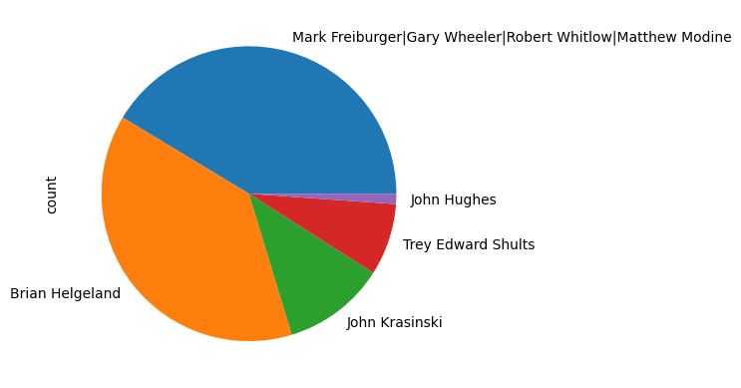

The most popular writer to work with were:

* + 1. Mark Freiburger|Gary Wheeler|Robert Whitlow|Matthew Modine
    2. Brian Helgeland

**Recommendations**

1. Microsoft should produce movies the Drama|Mystery and Suspence genre.

2. Microsoft should release its movies preferably in January on a Friday

3. Microsoft should aim to work with Gary Wheeler and Clint Eastwood as the directors of their movies

4. Microsoft should aim to work with the team of Mark Freiburger, Gary Wheeler, Robert Whitlow, Matthew Modine as the writers of their movies

**Next Steps**

1. Collect more data the average pay of different writers to outweigh with the estimated profits and find the most economical writers and directors to work with.

2. Collect more data on the preferred genres of specifically the demographic within Microsoft’s reach so as to make the analysis more accurate.